CS 306 ‘Library Management’ Project Step 4

Emir Asal 27933

In this project I wanted to create a website that can control multiple relational tables and present a useful system for a library management. In this library website users can send and receive book from another users. Also review system for each book in the database so that I planned to help user to find the correct book they like. I also planned Queue system initially since there must be way to keep track of the users that are waiting for a certain book. Furthermore, an account system was one of my initial specifications since we need to keep track of information of like who has the book and who commented on this book.
Website which can:
- Store the detailed information about books
- Store information about users that are on the library
- Review system that helps users to find the book they like
- Queue system if the book is currently taken to keep track of who can get the book next.

- Main page for this website is shown below and most of the operations are done from this page like ordering a book, donating book, entering a queue, registering an account, returning a book they previously borrowed, checking out the reviews and book details before they order a book.
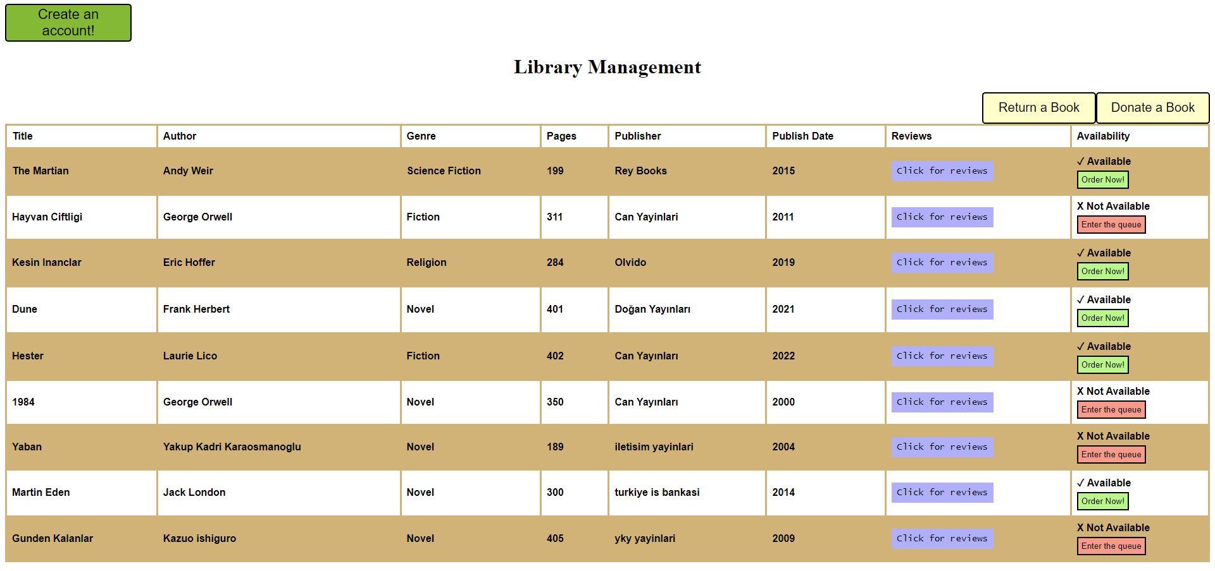
Information about the books is listed here and user can click the blue button to see the reviews about that book. Also, user can see if the book is currently occupied by another user if it is they can enter the queue for it and if it free they can directly receive that book.

In the main page for every row, each button has their own post method which contains that row’s book id later when clicked it will redirect the user to a certain page with that id.

- Registration Page: Users can access this page on the top left corner and send their data to the database later they will use their e-mail address for every other operation. In the below page data that was entered by the user will be inserted into the database.
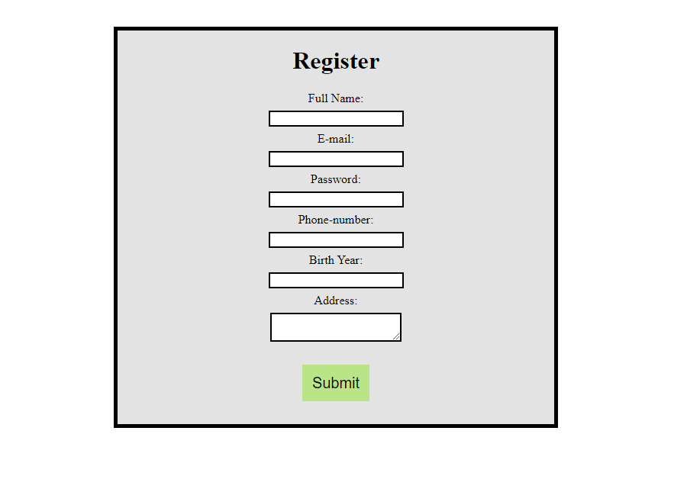

- Donate Book Page: Users can donate a book to the library, and it will be added to the database table for the books so other users can receive the donated book if they want. Information that was entered here will be displayed in the main page so the other users can see it.
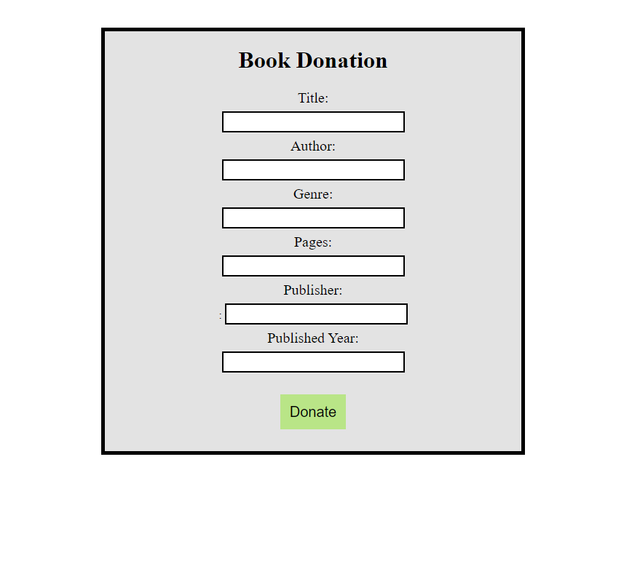

- Return Book Page: Users can return the book they have read simply by entering their email and the title of the book they borrowed, and it will be available for another user to borrow. Which will be shown in the main page if it is available or not. Input checks are also done because user can enter a wrong title and email.
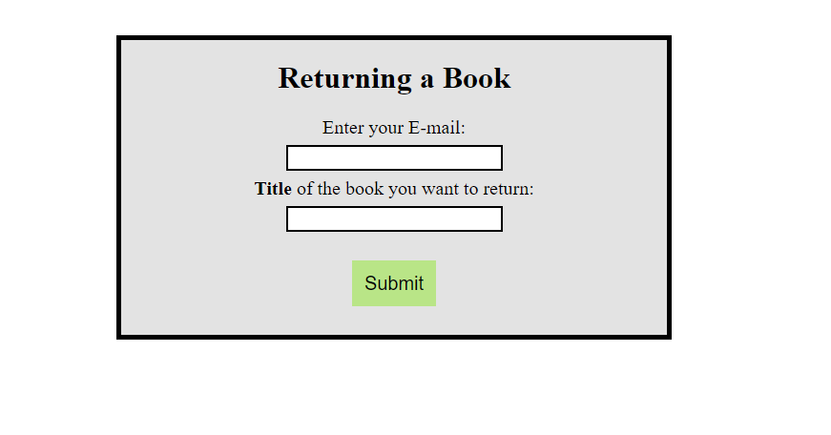

- Review Page: Every book has its own review page that can users comment and see the comments that were made by other users before them. To access a certain review page about a book a user should click the corresponding button on the main page. People can only comment if they are registered with their email to the website. If they are not, they will be notified to register.

Example Review Page For book “The Martian”:
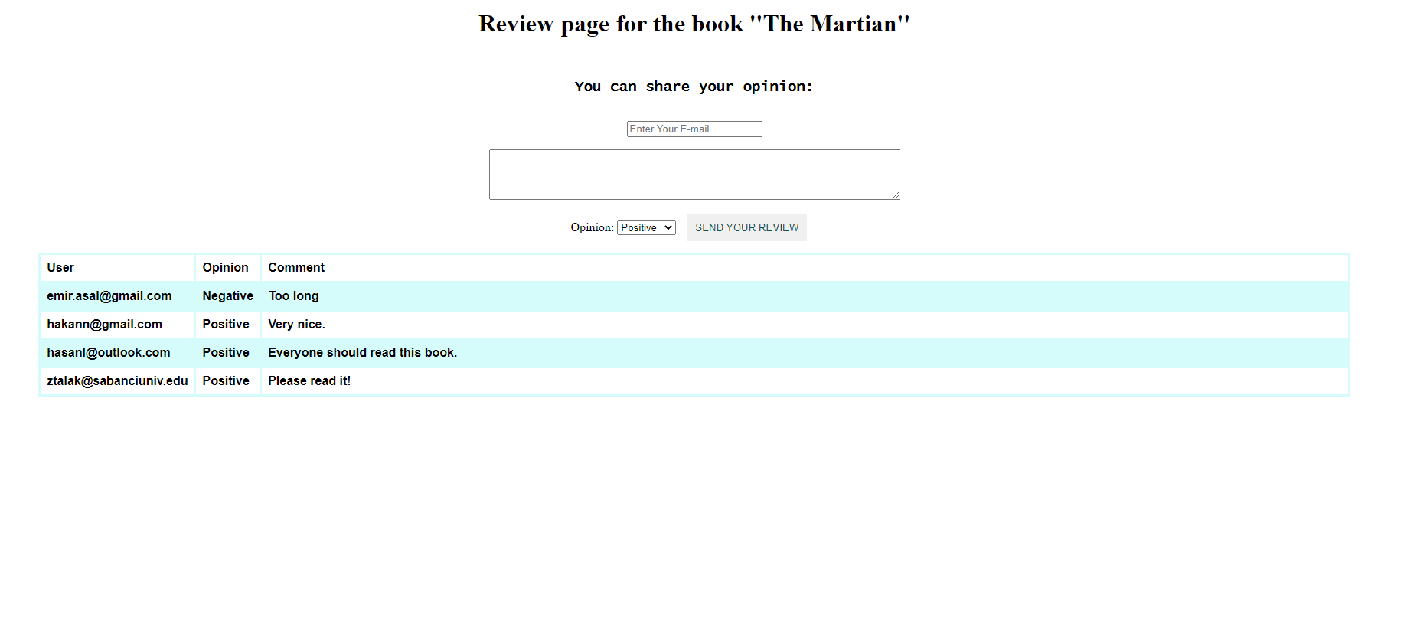

Another Review Page for book “Yaban”:
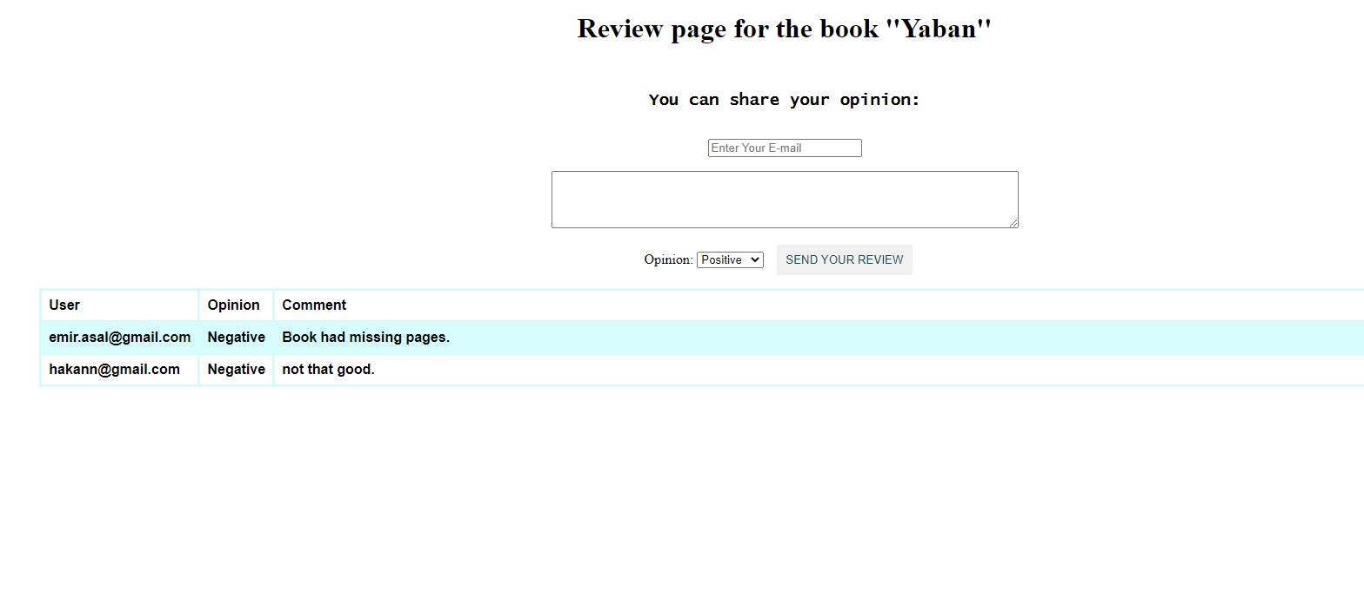

- Receive Book Page: As shown on the main page if the book is Listed as “Available” and “Order Now!” button is activated users can receive that book by using their e-mail addresses. When the corresponding button is pressed for the desired book below page will be visible. After correct email is entered that book will be registered for the entered email. If the wrong email is entered user will be notified.
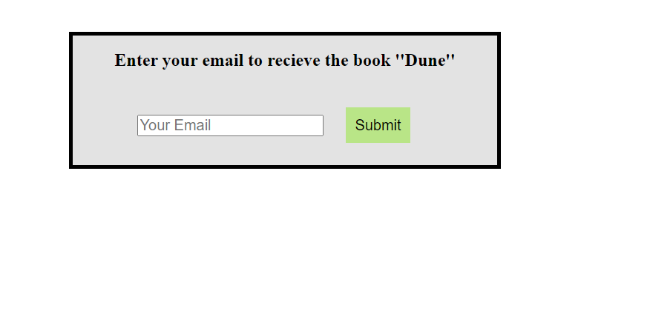

- Book Queue Page: If the book was previously taken by someone else a user can see the “Enter the queue” button from the main page and if that button is pressed, they can see if any other people want that book. If also the current user wants to receive this book, they can register their email address to the queue and they will be added to the list. If they enter non-registered email they will be notified with a message.
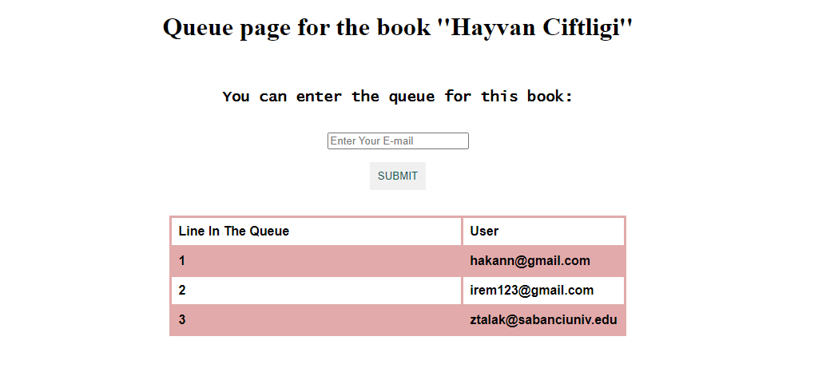Another Example queue page for the book “1984”:
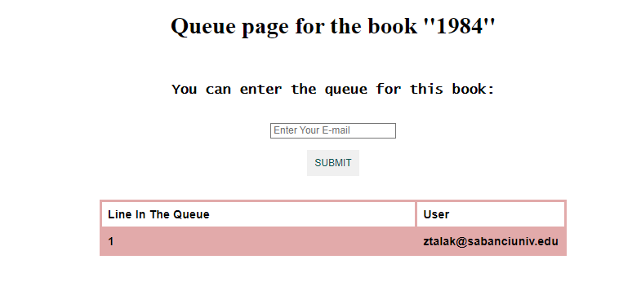

- Admin Page is used to control the tables of the database and update / delete information if needed. Some of the insertions can be done by anyone using the main page so admin page contains privileges that should not be done by regular users. Like deleting users, books, comments. Etc. Also some update methods like changing the position of the user on the queue. Finding out the private information about a certain user is also implemented so that only admin can see their information (like address and phone):
